### SOFTWARE REQUIREMENTS SPECIFICATION FOR ECOMMERCE WEBSITE

**WALMART**

**Done By-**

**Parth Agarwal**

### CONTENTS

### 1. Introduction

1.1 Purpose

1.2 Product Scope

1.3 References

2. Overall Description

2.1 Customer Service Perspective

2.2 Product Functions

2.3 User Classes and Characteristics

2.4 Design and Implementation Constraints

2.5 User Documentation

3. Developmental Processes Involved

3.1 Testing

3.2 Deployment

3.3 Maintenance

4. External Interface Requirements

4.1 User Interfaces

4.2 Hardware Interfaces

4.3 Software Interfaces

4.4 Communications Interfaces

5. System Features

6. Other Nonfunctional Requirements

6.1 Performance Requirements

6.2 Safety Requirements

6.3 Security Requirements

6.4 Software Quality Attributes

6.5 Business Rules

**1. Introduction**

## 1.1 Purpose

Walmart's current mission statement and its advertising slogan, which are prevalent at the company’s headquarters in Bentonville, Arkansas, the place where it all began are the same: "Save people money so they can live better." Based on this statement, it is clear that Walmart’s business strategies involve using price as a selling point to attract target consumers. The significance of such a selling point is exhibited in many of the company’s strategies. For example, [Walmart Inc.’s marketing mix or 4P](http://panmore.com/walmart-marketing-mix-4ps-analysis-recommendations) involves low prices as a strategy. Other areas of the company are determined by the need to minimize selling prices as a way to achieve competitiveness.

## 1.2 Product Scope

* Secure registration and profile management facilities for customers
* Adequate searching mechanisms for easy and quick access to particular products and services.
* Creating a shopping cart so that customers can shop many items and checkout finally with the entire shopping carts. Customers can add or delete items in the cart.
* Regular updates to registered customers about new arrivals.
* Strategic data and graphs for administrators and shop owners about the items that are popular in each category and age group.
* Maintaining database of regular customers of different needs.
* Shop employees are responsible for internal affairs like processing orders, assure home delivery, getting customer's delivery-time feedback, updating order's status and answering client's queries online.
* Feedback mechanism, so that customers can give feedback for the product or service which they have purchased. Also facility rating of individual products by relevant customers.
* Adequate payment mechanism and gateway for all popular credit cards, cheques and other relevant payment options, as available from time to time.

## 1.3 References

* [Walmart's History and Mission Statement (thebalancesmb.com)](https://www.thebalancesmb.com/history-of-walmart-and-mission-statement-4139760)
* [Walmart’s Mission Statement & Vision Statement, Generic & Intensive Strategies - Panmore Institute](http://panmore.com/walmart-vision-mission-statement-intensive-generic-strategies)
* [Walmart: The Customer Service Perspective - 768 Words | Bartleby](https://www.bartleby.com/essay/Walmart-The-Customer-Service-Perspective-FKVJT6FMY6FS)

# 2. Overall Description

## 2.1 Customer Service Perspective

## Walmart's expertise in discount retailing is globally recognized, as is their supply chain and extensive logistics capabilities. They have extensive reliance on buyer personas or representations of their customers. All aspects of the Walmart value chain are predicated on serving their customers as cost effectively and efficiently as possible. Walmart has also created an extensive information systems network that includes satellite uploads of data on a daily basis from their thousands of retail locations to their Bentonville, Arkansas headquarters. The intent of this analysis is to evaluate the mission, vision and strategy of Walmart from the perspective of improving its customer service while also taking into account its financial position. To accomplish this, objectives are provided, combined with performance measures and expected levels of performance as well. All of these factors taken together provide senior management at Walmart with insights into how they can profitably improve customer service.

## 2.2 Product Functions

* The main purpose of this project is to reduce the manual work.
* Functions: A customer can browse through the shops and choose products to place in a virtual shopping cart. The shopping cart details can be viewed and items can be removed from the cart. To proceed with the purchase, the customer is prompted to login. Also, the customer can modify personal profile information (such as phone number and shipping address) stored by the application. The customer can also view the status of any previous orders, and cancel any order that has not been shipped yet.

2.3 User Classes and Characteristics

* The user should be familiar with the shopping mall related terminology like shopping cart/checking out/transaction etc.
* The user should be familiar with the internet.

2.4 Design and Implementation Constraints

An online store is a virtual store on the internet where customers can browse the catalogue and select products of interest. The selected items may be collected in a shopping cart. At checkout time, the items in the shopping cart will be presented as an order. At that time, more information will be needed to complete the transaction. Usually, the customer will be asked to fill or select a billing address, a shipping address, a shipping option, and payment information such as credit card number. An e-mail notification is sent to the customer as soon as the order is placed

## 2.5 User Documentation

The product will include user manual. The user manual will include product overview, complete configuration of the used software, technical details, backup procedure and contact information which will include email address. There will be no online help for the product at this moment. The product will be compatible with current version of all browsers. The databases will be created in the MySQL.

# 3. Developmental Processes Involved

**3.1 Testing**

Testing is the process of executing the program with the aim of finding the errors. To make our software perform well, it should be error-free. If testing is done successfully, it will remove all the errors from the software.

Principles of Testing followed:-

1. All the testcases should meet the customer requirements.
2. The testing should be performed by the third party.
3. Exhaustive testing is not possible as we need an optimal amount of testing based on the risk assessment of the application.
4. All the test to be conducted should be planned before the implementation.
5. Start testing with small parts and then extend to large parts.

Different testing is performed:-

1. Regression Testing- Every time a new module is added, it leads to new changes in the program. This type of testing makes sure that whole component works properly even after adding these new components to the complete program.
2. Alpha Testing- This is a type of validation testing. It’s a type of acceptance testing which is done before the product is released to the customers. It is typically done by QA people.
3. Beta Testing- The beta test is conducted at one or more customer sites by the end-user of the software. This version is released for a limited number of users for testing in a real-time environment.
4. System Testing- This software is tested such that it works fine for all different operating systems. It is covered under the black box testing technique. In this, we just focus on the required input and output without focusing on internal working. We have security testing, recovery testing, stress testing and performance testing.

3.2 Deployment

The deployment phase is run after one or more testing phases to put the latest increment into production. Some projects have only one deployment at the end, some have a few deployments (e.g., one after every 5 iterations of development), and some deploy every iteration.

Agile projects, in general, prefer to have deployments (releases) throughout the project. When the product is not deployed, it’s only seen by the customer and a few end-user representatives, which generates limited feedback. On the other hand, when the product is deployed, a wide range of end-users will be using it, and the feedback will be more reliable.

3.3 Maintenance

In the software life cycle, the maintenance phase is the last stage of the cycle. After software passes the design stage and is implemented, the maintenance phase of the software life cycle begins. Understanding the characteristics of the maintenance phase of the software life cycle allows individuals tasked with analyzing the performance of the software after deployment to correctly resolve issues that arise.

After software is up and running, it often requires continuous maintenance. In general, software remains operational for an extended period of time after initial implementation and requires regular maintenance to ensure that the software operates continually at peak performance levels. During the maintenance phase of the software life cycle, software programmers regularly issue software patches to address changes in the needs of an organization, to correct issues relating to bugs in the software or to resolve potential security issues. Throughout the maintenance phase, designers address issues that are discovered to prevent any hindrance to the expected performance of the software or to add increased functionality to the software.

# 4. External Interface Requirements

# 4.1 User Interfaces

* Admin can view, edit and delete everything on the product.
* User can view the whole information.

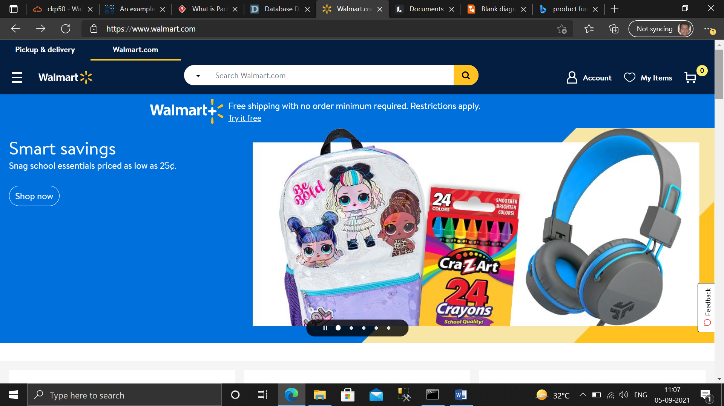

**Home page view**

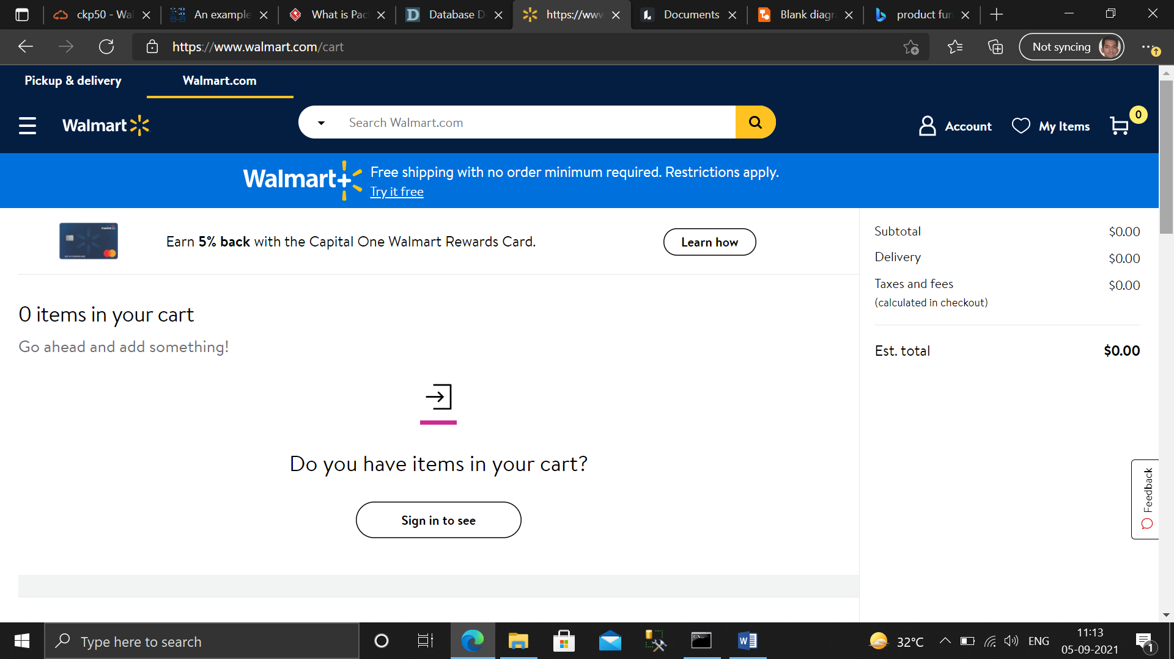

CART Page

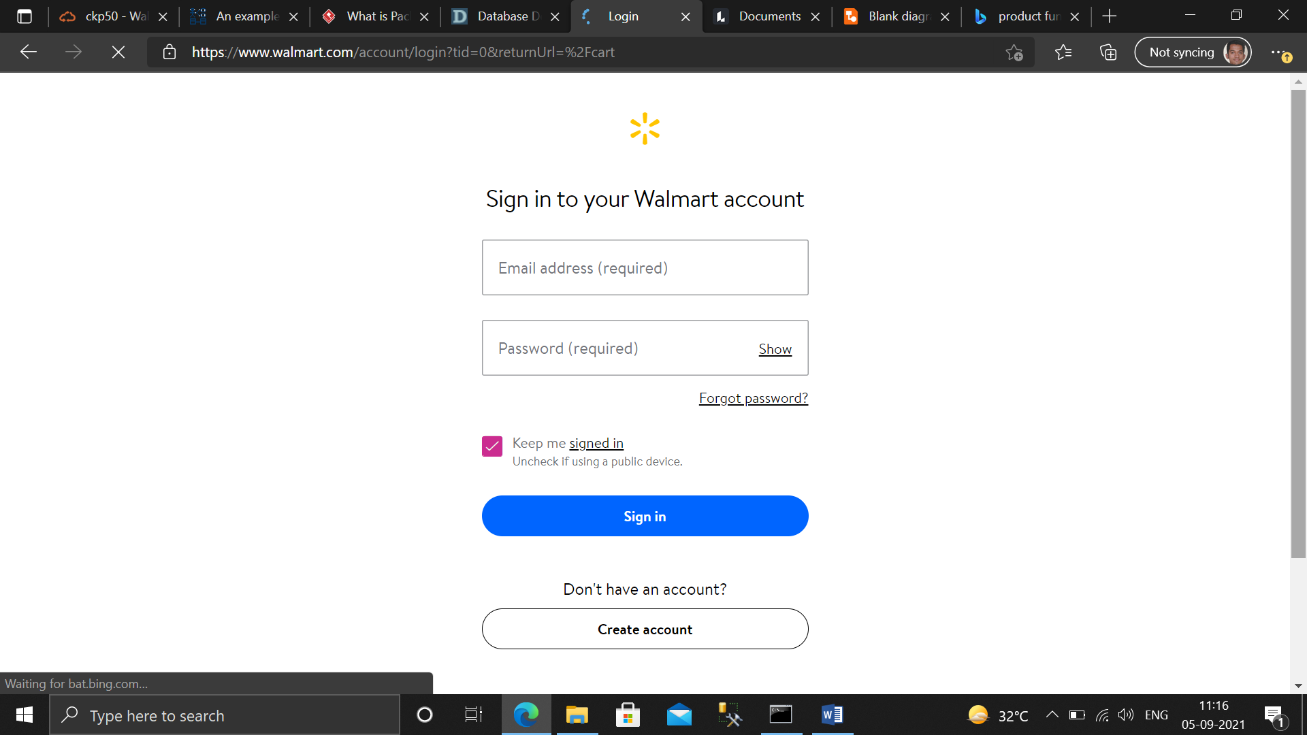

**Login page**

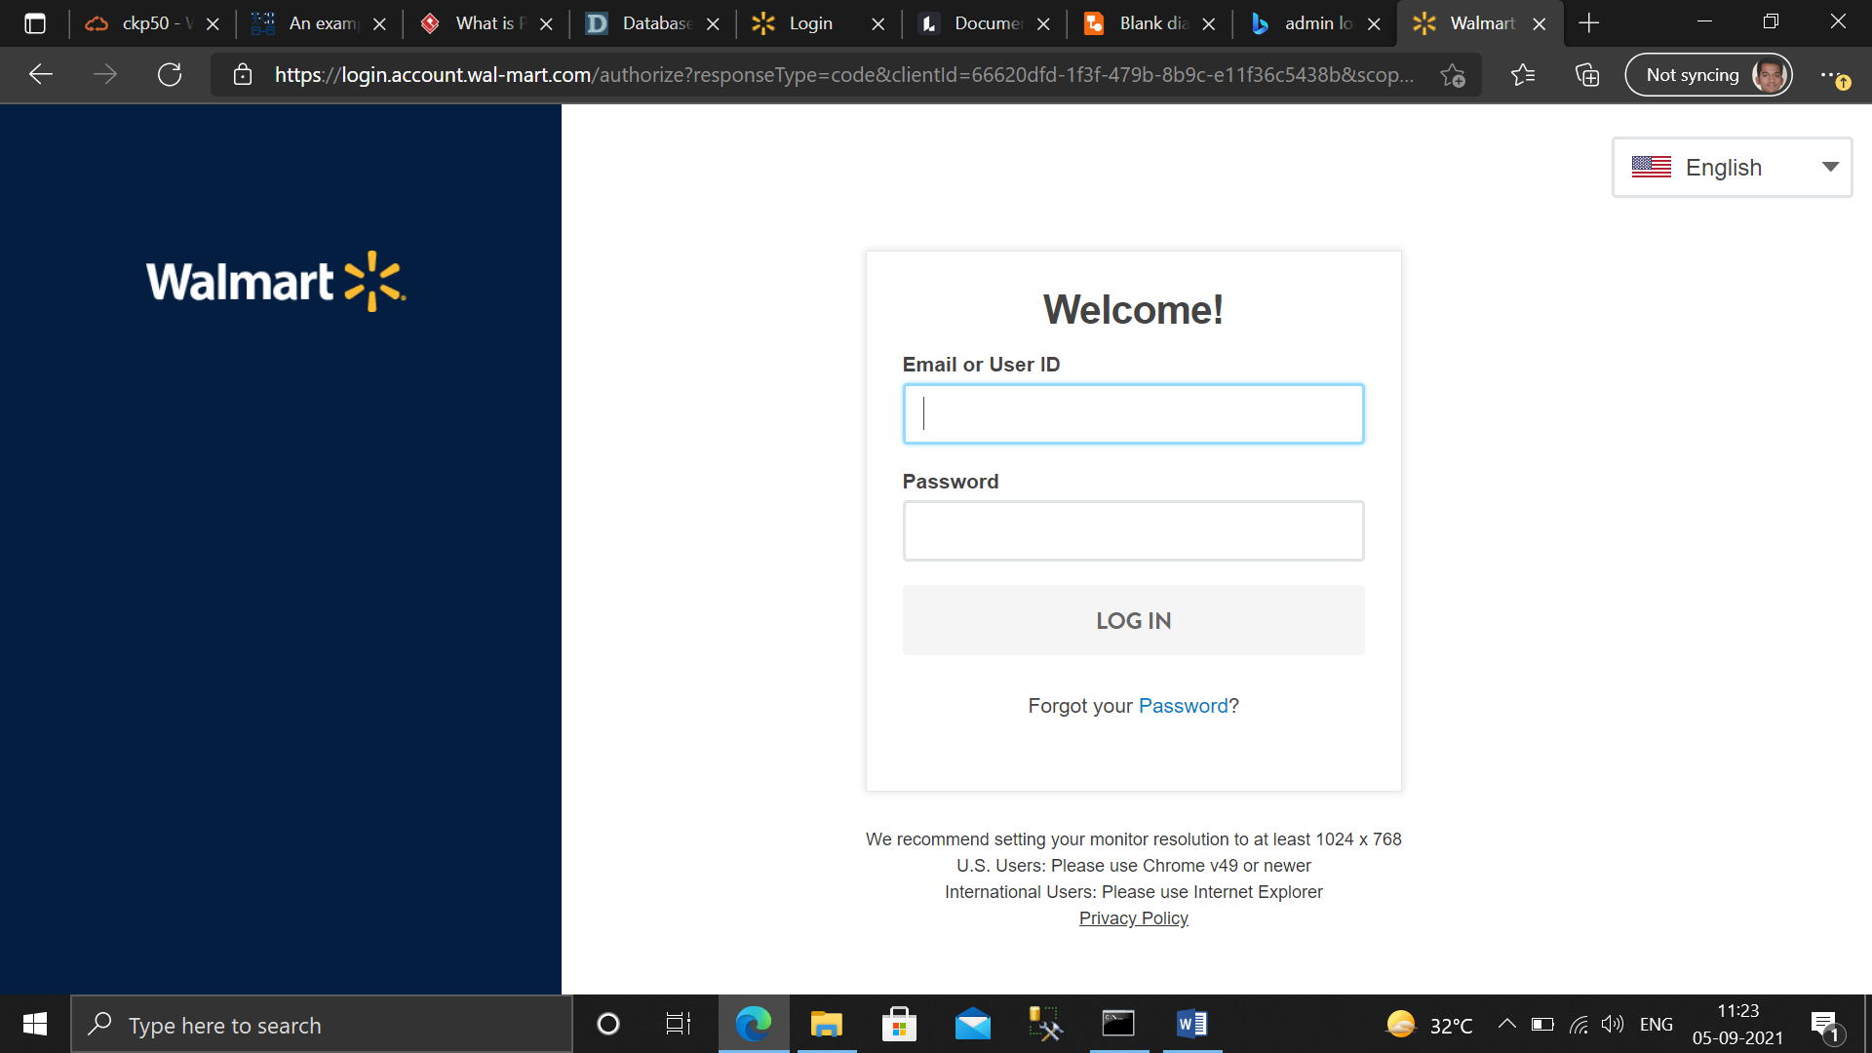

**Admin login**

## 

## 4.2 Communications Interfaces

The customer must connect to the internet to access the website:

* Dialup Modem of 52 kbps
* Broadband Internet
* Dialup or Broadband Connection with a Internet Provider.

# 5. System Features

* The website authority should ensure the customer is provided with real product.
* Customer support is available from the authority ➢ Customer information security confirm.
* Manage customer information.
* To increase efficiency of managing the authority work

# 6. Other Non-functional Requirements

## 6.1 Performance Requirements

There is no performance requirement in this system because the server request and response are dependent on the end user internet connection.

## 

## 6.2 Safety Requirements

The database may get crashed at any certain time due to virus or operating system failure. Therefore, it is required to take the database backup so that the database is not lost. Proper UPS/ Inverter facility should be there in case of power supply failure.

## 6.3 Security Requirements

* System will use secured database.
* Normal users can just read information but they cannot edit or modify anything except their personal and some other information.
* System will have different types of users and every user has access constraints.

## 6.4 Software Quality Attributes

* There may be multiple admins creating the project, all of them will have the right to create changes to the system. But the members or other users cannot do changes.
* The product should be open source.
* The quality of the database is maintained in such a way so that it can be very user friendly to all the users of the database.
* The user will be able to easily download and install the system.

## 6.5 Business Rules

A business rule is anything that captures and implements business policies and practices. A rule can enforce business policy, make a decision, or infer new data from existing data. This includes the rules and regulations that the system users should abide by. This includes the cost of the project and the discount offers provided. The users should avoid illegal rules and protocols. Neither admin nor members should cross the rules and regulations.